TABLES:

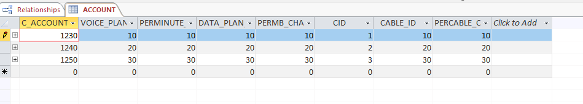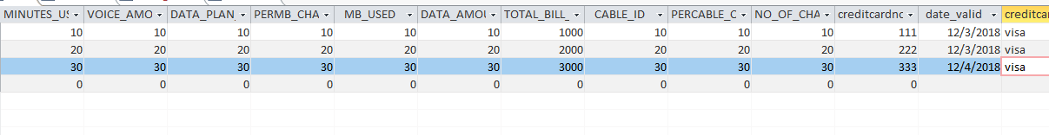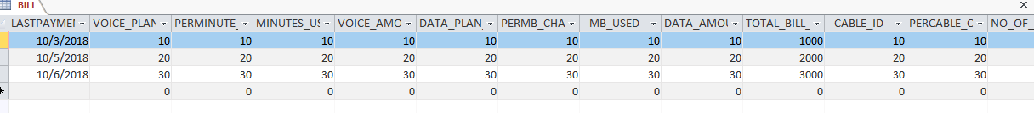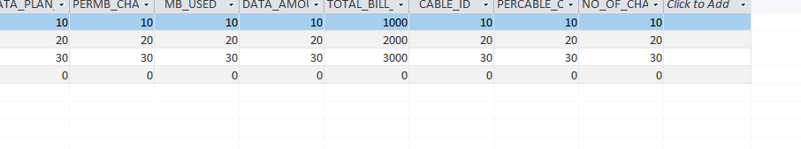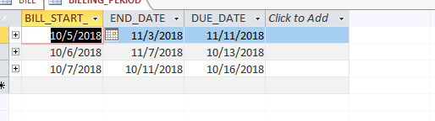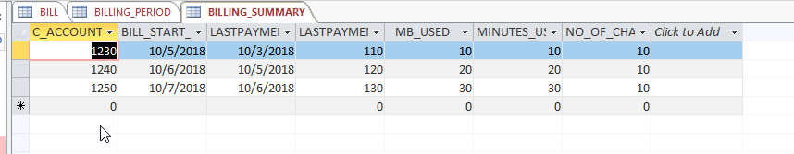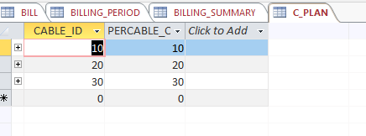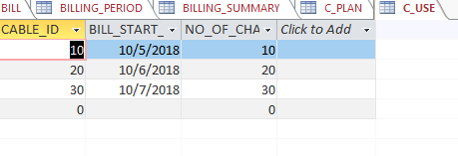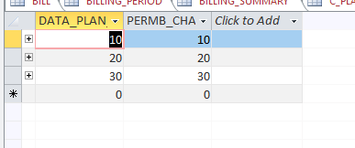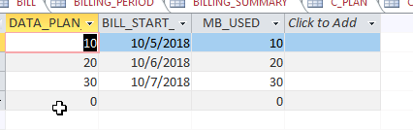

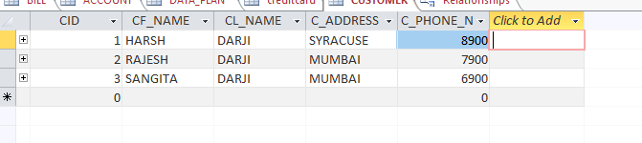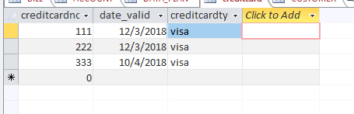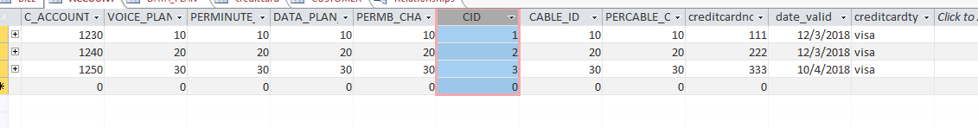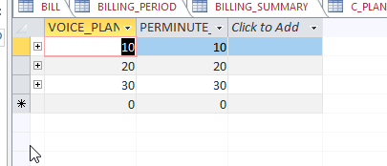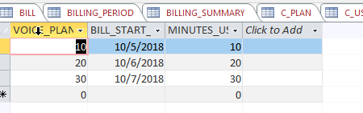

1NF:

1. Each customer must have at least one account with Orange Digital Company.
2. Each customer must have at least one credit card for bill payment.
3. Each account must have at least one of the connections, e.g., telephone/internet / cable.
4. Telephone account number is not the same as Internet connection account number or cable account number.
5. Each telephone account number is associated with one and only one customer account number.
6. Each internet connection account number is associated with one and only one customer account number.
7. Each cable account number is associated with one and only one account number.
8. Current charge is the summation of telephone, internet connection and cable billed amounts for the billing period. There are no adjustments from previous cycles.

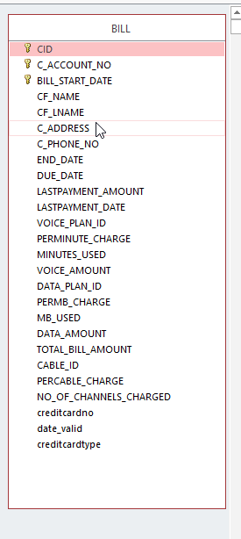

2NF:

Each wireless bill can be uniquely identified using a combination of CustomerId,

Account No. and Start Date. Therefore, CustomerId, Account No. and Start Date form a

composite primary key for the table in 1NF

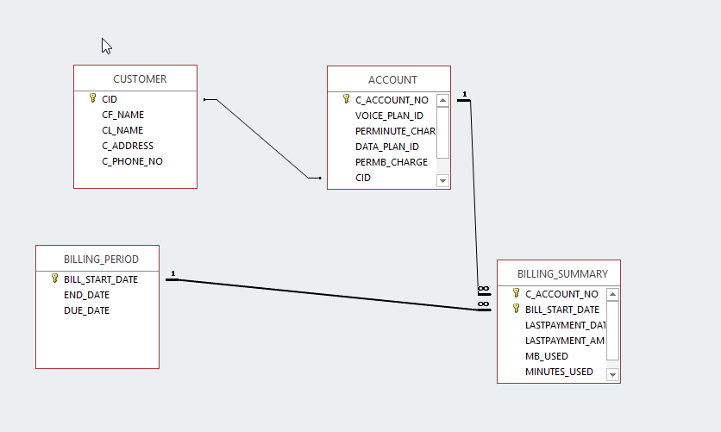

3NF:

Partial dependencies must be eliminated to convert the data model from 1NF to 2NF.

A partial dependency exists when a non-key attribute is dependent on part of the primary

key (which in this case is a combination of Account No. and Start Date).

